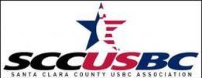

Santa Clara County USBC Association

Monthly Board Member Report

Date: _________________

Name: ___________________________

Bowling Center Visits

Tournament / Event Promotion

Committee(s) Activity

Suggestions / Recommendations / Concerns

